Project Sprint #1

The Solitaire game is described in CS449HomeworkOverview. You should read the description very carefully.

In this assignment, you aim to specify the requirements (i.e., user stories and acceptance criteria) of the target software that allows a human player to play a Solitaire game. These requirements will be fully implemented by the end of sprint 3. The minimum features include choosing the board size and type, starting a new game, making a move, determining if a game is over. The following is a sample GUI layout.

Board size
7
Board Type  - English  - Hexagon  - Diamond | 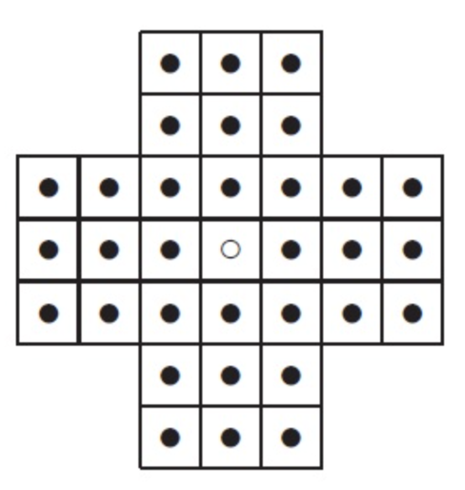 | New Game
Figure 1. Sample GUI layout of the first working program by the end of Sprint 3

Use the following tables to document your user stories and acceptance criteria.

You are required to use the free ChatGPT or another LLM to complete two user stories and two of their respective acceptance criteria. You must ensure that the generated user stories are correct and fix them if not. At the end of the submission, provide screenshots of your LLM prompts and answers, along with the description of errors the LLM made that you had to correct. Points will be deducted if no screenshots/description are provided.

For the other user stories and acceptance criteria, you are not required to use LLM.

- User Stories (3 points)

- User Story Template: As a <role>, I want <goal> [so that <benefit>]

ID | User Story Name | User Story Description | Priority | Estimated effort (hours)
1 | Choose a board size | As a player, I want to select the size of the game board when starting a new game so that I can play peg solitaire on boards of different sizes. | 1
2 | Choose the board type | As a player, I want to select the type of game board when starting a new game so that I can play peg solitaire on boards of different shapes. | 1
3 | Start a new game of the chosen board size and type | As a player, I want to start a new game of the selected size and type so that I can play peg solitaire on boards of the selected type and shape. | 2
4 | Make a move in a game | As a player, I want to make a valid move by selecting a peg and an adjacent empty space so that I can remove pegs and progress toward the goal of the game. | 3
5 | A game is over | As a player, I want the game to detect when the game is over, so that I can assess how well I played and know when to start a new game. | 4

- Acceptance Criteria (AC) (12 points): Add/delete rows as needed.

User Story ID and Name | AC  ID | Description of Acceptance Criterion | Status (completed, toDo, inPprogress)
1. Choose a board size | 1.1 | AC 1.1 Selecting a supported board size in a newly generated game  Given the player has started a new game  And the player has not yet made a move  When the player selects a supported board size  Then the selected board size is used to create a new game board.
1. Choose a board size | 1.2 | AC 1.2 Displaying available board sizes  Given the player is starting a new game  When the player goes to select a board size  Then all supported board sizes are available for selection.
1. Choose a board size | 1.3 | AC 1.3 Creating the selected board  Give the player has selected a supported board size  When the player starts the game  Then the game displays a board matching the selected size.
1. Choose a board size | 1.4 | AC 1.4 Selecting an unsupported board size  Given the player has started a game,  When the player selects an unsupported board size  Then the board size selection reverts to its last state  And no new board is generated.
2. Choose the board type | 2.1 | AC 2.1 Selecting a board type in a newly generated game  Given the player has started a new game  And the player has not yet made a move  When the player selects a board type  Then the selected board type is used to create a new game board.
2. Choose the board type | 2.2 | AC 2.2 Displaying available board types  Given the player is starting a new game  When the player goes to select a board type  Then all supported board types are available for selection.
2. Choose the board type | 2.3 | AC 2.3 Creating the selected board  Given the player has selected a board type  When the player starts the game  Then the game displays a board matching the selected type.
3. Start a new game of the chosen board size and type | 3.1 | AC 3.1 Starting a new game  Given the player has selected a board type and valid board size  When the player starts a game  Then a new board of the selected type and size is generated  And all spaces in the board except the starting hole are filled.
4. Make a move in a game | 4.1 | AC 4.1 Making a valid move  Given a game is in progress and a valid move is available  When the player selects a peg and a valid destination  Then the selected peg moves to the destination and the jumped peg is removed.
4. Make a move in a game | 4.2 | AC 4.2 Rejecting an invalid move  Given a game is in progress  When the player attempts to make an invalid move  Then the board remains unchanged.
4. Make a move in a game | 4.3 | AC 4.3 Moving only according to the board rules  Given a game is in progress  When the player attempts to make a move  Then the move is accepted only if it follows the movement rules for the selected board type.
4. Make a move in a game | 4.4 | AC 4.4 Updating the game state  Given the player has made a valid move  When the move is completed  Then the game board reflects the new positions of the pegs.
5. A game is over | 5.1 | AC 5.1 Determining whether the game is over  Given the player has completed a valid move  When there are no valid moves remaining  Then the game is identified as being over.
5. A game is over | 5.2 | AC 5.2 Displaying the player’s score  Given the player has completed a valid move,  When the game is identified as being over,  Then the player is shown their score based on the number of remaining pegs  And is prompted to start a new game.

